Task 1 Report: Responsive Web Design Portfolio Website
1. Task Title
Responsive Personal Portfolio Website

2. Objective
To design and develop a responsive personal portfolio website using HTML, CSS, and Bootstrap.
The website showcases my profile, technical skills, projects, and contact information.

3. Technologies Used
- HTML5
- CSS3
- Bootstrap 5
- Git
- GitHub
- GitHub Pages (Hosting)

4. Project Description
This project is a responsive portfolio website created to present my technical skills and projects in a professional way.
The website contains:
- Home section
- Skills section
- Projects section
- Contact section
- Responsive navigation bar
- Interactive hover effects

5. Project Structure
Portfolio/
│
├── index.html
├── style.css
├── images/
│ ├── profile.png
│ ├── python.png
│ ├── java.png
│ ├── html.png
│ └── other skill images
│
└── README.md

6. Screenshots
Homepage Screenshot
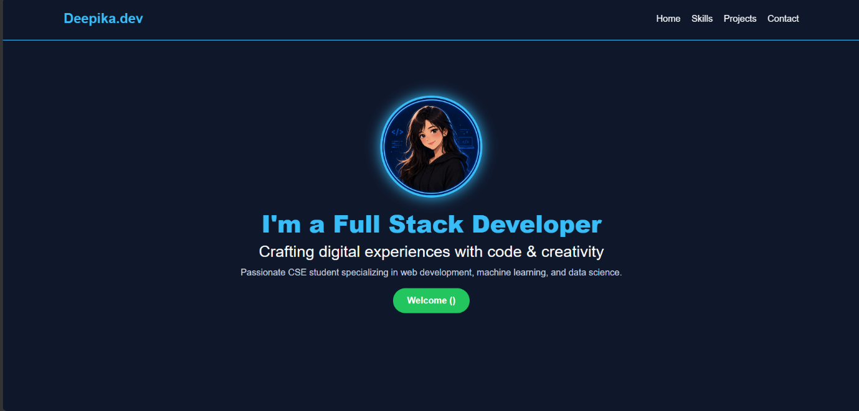
Skills Section Screenshot
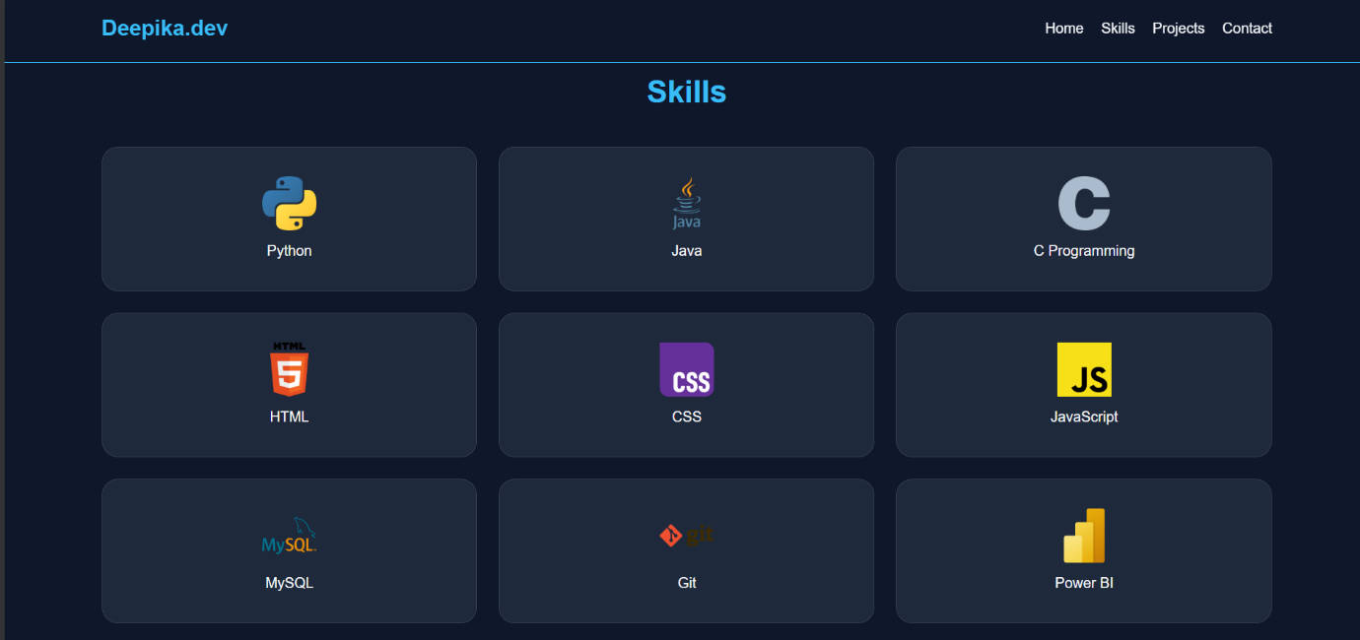

Projects Section Screenshot
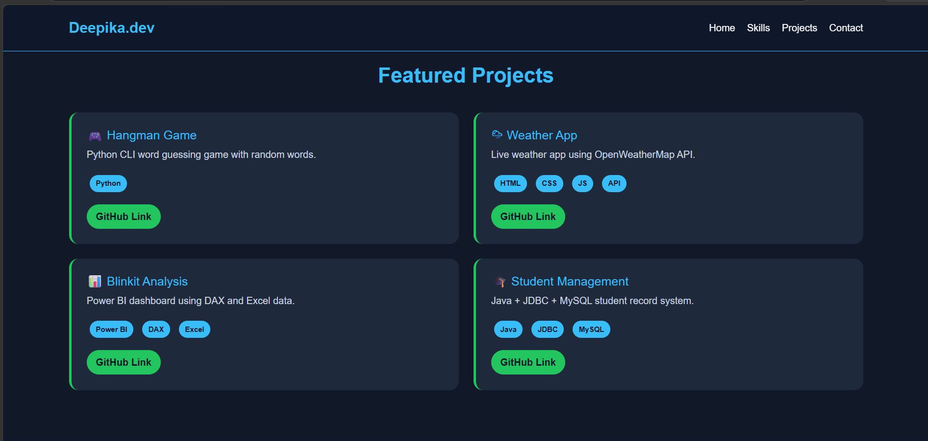
7. Code Snippets
HTML
<!DOCTYPE html>
<html lang="en">

<head>
<meta charset="UTF-8">
<meta name="viewport" content="width=device-width, initial-scale=1.0">
<title>Deepika Portfolio</title>
<link href="https://cdn.jsdelivr.net/npm/bootstrap@5.3.3/dist/css/bootstrap.min.css" rel="stylesheet">
<link rel="stylesheet" href="style.css">
</head>

<body>
<!-- NAVBAR -->
<nav class="navbar navbar-expand-lg fixed-top">
<div class="container">
<a class="navbar-brand" href="#">Deepika.dev</a>
<div class="ms-auto nav-links">
<a href="#home">Home</a>
<a href="#skills">Skills</a>
<a href="#projects">Projects</a>
<a href="#contact">Contact</a>
</div>
</div>
</nav>

<!-- HOME -->
<section id="home" class="home">
<div class="container text-center">
<img src="images/profile.png" class="profile">
<h1>I'm a Full Stack Developer</h1>
<h3>Crafting digital experiences with code & creativity</h3>
<p>
Passionate CSE student specializing in web development,
machine learning, and data science.
</p>
<button class="btn btn-primary">Welcome ()</button>
</div>
</section>

<!-- SKILLS -->
<section id="skills">
<div class="container">
<h2>Skills </h2>
<div class="row g-4">

<!-- Languages -->
<div class="col-md-4 col-sm-6">
<div class="skill-card">
<img src="images/python.png">
<p>Python</p>
</div>
</div>

<div class="col-md-4 col-sm-6">
<div class="skill-card">
<img src="images/java.png">
<p>Java</p>
</div>
</div>

<div class="col-md-4 col-sm-6">
<div class="skill-card">
<img src="images/c.png">
<p>C Programming</p>
</div>
</div>

<div class="col-md-4 col-sm-6">
<div class="skill-card">
<img src="images/html.png">
<p>HTML</p>
</div>
</div>

<div class="col-md-4 col-sm-6">
<div class="skill-card">
<img src="images/css.png">
<p>CSS</p>
</div>
</div>

<div class="col-md-4 col-sm-6">
<div class="skill-card">
<img src="images/js.png">
<p>JavaScript</p>
</div>
</div>

<div class="col-md-4 col-sm-6">
<div class="skill-card">
<img src="images/mysql.png">
<p>MySQL</p>
</div>
</div>

<div class="col-md-4 col-sm-6">
<div class="skill-card">
<img src="images/git.png">
<p>Git</p>
</div>
</div>

<div class="col-md-4 col-sm-6">
<div class="skill-card">
<img src="images/powerbi.png">
<p>Power BI</p>
</div>
</div>

<div class="col-md-4 col-sm-6">
<div class="skill-card">
<img src="images/dbms.jpg">
<p>DBMS</p>
</div>
</div>

</div>
</div>
</section>

<!-- PROJECTS -->
<section id="projects">
<div class="container">
<h2>Featured Projects</h2>
<div class="row g-4">
<!-- 1 -->
<div class="col-md-6">
<div class="project-card">
<h3>🎮 Hangman Game</h3>
<p>Python CLI word guessing game with random words.</p>
<div class="tags">
<span>Python</span>
</div>
<a href="https://github.com/saideepika-29/hangman-word-guessing-game" target="_blank">
GitHub Link
</a>
</div>
</div>
<!-- 2 -->
<div class="col-md-6">
<div class="project-card">
<h3>🌦 Weather App</h3>
<p>Live weather app using OpenWeatherMap API.</p>
<div class="tags">
<span>HTML</span>
<span>CSS</span>
<span>JS</span>
<span>API</span>
</div>
<a href="https://github.com/saideepika-29/weather_application" target="_blank">
GitHub Link
</a>
</div>
</div>
<!-- 3 -->
<div class="col-md-6">
<div class="project-card">
<h3>📊 Blinkit Analysis</h3>
<p>Power BI dashboard using DAX and Excel data.</p>
<div class="tags">
<span>Power BI</span>
<span>DAX</span>
<span>Excel</span>
</div>
<a href="https://github.com/saideepika-29/blinkit-Sales-Analysis" target="_blank">
GitHub Link
</a>
</div>
</div>
<!-- 4 -->
<div class="col-md-6">
<div class="project-card">
<h3>🎓 Student Management</h3>
<p>Java + JDBC + MySQL student record system.</p>
<div class="tags">
<span>Java</span>
<span>JDBC</span>
<span>MySQL</span>
</div>
<a href="https://github.com/saideepika-29/student-management-system" target="_blank">
GitHub Link
</a>
</div>
</div>
</div>
</div>
</section>

<!-- CONTACT -->
<section id="contact">
<div class="container text-center">
<h2>Contact</h2>
<p>Email: saideepikasabbella@gmail.com</p>
<p>GitHub: github.com/saideepika-29</p>
</div>
</section>

<!-- FOOTER -->
<footer>
<p>© 2026 Deepika Portfolio</p>
</footer>
</body>

</html>

CSS Example
/* ROOT COLORS */
:root {
--bg: #0F172A;
--primary: #38BDF8;
--text: #F8FAFC;
--accent: #22C55E;
}

/* GLOBAL */
html {
scroll-behavior: smooth;
}

body {
margin: 0;
font-family: Arial, sans-serif;
background: var(--bg);
color: var(--text);
}

/* NAVBAR */
.navbar {
background: rgba(15, 23, 42, 0.95);
border-bottom: 1px solid var(--primary);
padding: 15px 0;
backdrop-filter: blur(10px);
}

.navbar-brand {
color: var(--primary);
font-size: 24px;
font-weight: bold;
}

.nav-links a {
color: var(--text);
margin-left: 15px;
text-decoration: none;
transition: 0.3s;
font-weight: 500;
}

.nav-links a:hover {
color: var(--accent);
}

/* HERO SECTION */
.home {
min-height: 100vh;
display: flex;
align-items: center;
justify-content: center;
text-align: center;
padding: 20px;
}

.profile {
width: 180px;
height: 180px;
border-radius: 50%;
border: 4px solid var(--primary);
box-shadow: 0 0 25px var(--primary);
margin-bottom: 20px;
transition: 0.3s;
}

.profile:hover {
transform: scale(1.05);
}

h1 {
color: var(--primary);
font-size: 42px;
font-weight: 800;
}

h3 {
color: var(--text);
font-weight: 400;
}

p {
color: #cbd5e1;
font-size: 16px;
}

/* BUTTON */
.btn-primary {
background: var(--accent);
border: none;
padding: 10px 25px;
border-radius: 25px;
color: white;
font-weight: bold;
transition: 0.3s;
}

.btn-primary:hover {
background: var(--primary);
color: var(--bg);
transform: scale(1.05);
}

h2 {
text-align: center;
color: var(--primary);
margin: 60px 0 40px;
font-size: 34px;
font-weight: bold;
}

/* SKILLS SECTION */
.skill-card {
background: #1E293B;
border-radius: 18px;
padding: 25px;
text-align: center;
border: 1px solid #334155;
transition: 0.3s;
height: 160px;
display: flex;
flex-direction: column;
align-items: center;
justify-content: center;
}

.skill-card img {
width: 60px;
height: 60px;
object-fit: contain;
margin-bottom: 10px;
transition: 0.3s;
}

.skill-card p {
color: var(--text);
margin: 0;
font-weight: 500;
}

.skill-card:hover {
transform: translateY(-10px);
border: 1px solid var(--accent);
box-shadow: 0 0 20px rgba(56, 189, 248, 0.5);
background: #0F172A;
}

.skill-card:hover img {
transform: scale(1.2);
}

/* PROJECT SECTION */
#projects {
padding: 80px 0;
background: #111827;
}

.project-card {
background: #1E293B;
padding: 25px;
border-radius: 15px;
border-left: 4px solid var(--accent);
transition: 0.3s;
height: 100%;
}

.project-card:hover {
transform: translateY(-8px);
box-shadow: 0 0 20px var(--primary);
}

.project-card h3 {
color: var(--primary);
font-size: 20px;
}

.project-card p {
color: #cbd5e1;
}

.tags span {
display: inline-block;
margin: 5px;
padding: 5px 10px;
border-radius: 15px;
background: var(--primary);
color: #0F172A;
font-size: 12px;
font-weight: bold;
}

/* PROJECT LINK BUTTON */
.project-card a {
display: inline-block;
margin-top: 15px;
background: var(--accent);
color: #0F172A;
padding: 8px 15px;
border-radius: 20px;
text-decoration: none;
font-weight: bold;
transition: 0.3s;
}

.project-card a:hover {
background: var(--primary);
transform: scale(1.05);
}

/* CONTACT */
#contact {
padding: 80px 0;
text-align: center;
}

#contact p {
font-size: 18px;
color: #cbd5e1;
}

/* FOOTER */
footer {
text-align: center;
padding: 15px;
border-top: 1px solid var(--primary);
color: var(--text);
background: #020617;
}

/* RESPONSIVE */
@media(max-width:768px) {

h1 {
font-size: 30px;
}

.skill-card {
height: 150px;
}

}

8.GitHub Repository Link
Add your repository link:
https://github.com/saideepika-29/InternSpark-_Internship_task-1_ResponsivePortfolioWebsite

10. Hosted Website Link
GitHub Pages Link:
https://saideepika-29.github.io/InternSpark-_Internship_task-1_ResponsivePortfolioWebsite/

11. Conclusion
The responsive portfolio website was successfully developed and hosted.
This project demonstrates my frontend development skills and ability to create responsive web applications.

12. Author
Deepika
GitHub: https://github.com/saideepika-29

